Research

## **- How to make a website attractive to teenagers?**

The main focus of my website is to be able to offer a wide range of useful GCSE revision material for students who are currently taking subjects such as Maths, Science and English. Therefore the younger audience is the target for the website. *This generation is much more tech savvy than previous generations, and their values and styles of navigating, shopping and using the internet have changed. (*John stone, 2016*)* In summary, the ‘Gen Z’ are after a few things: fast and convenient information, content that’s funny and personal, and products and services that focus on their long term goals while also giving them instant gratification.

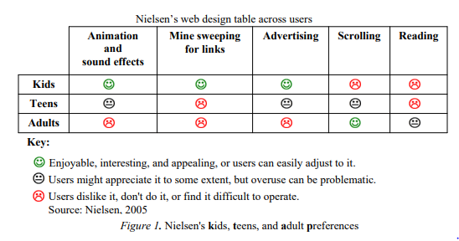

Based on this graph (Anthony S. Chow, Kathelene McCarty Smith

and Katherine Sun, 2012), is fair to assume that teens are one of the most demanding age groups as their requirements from a website are quite high and meticulous. From is table I can deduce the functions that my website should, or shouldn’t have, like:

Do: animation effects e.g. Info carousel. This adds a more modern look to the website which is what teens are looking for.

Do: add some scrolling to the page. Some scrolling in the page is necessary as the is a lot of information to share in the website, but I should keep it limited as

Don’t: add advertising. Although is represented as a neutral view in the table, ads are often considered annoying, which usually leads to a website being less attractive and entertaining.

Don’t: create long texts as teenagers may grow tired of reading through useless information that they are not interested in.

## **- Programming languages to design and create a website**

In order to start creating the website I had to do extensive research on the different existing languages that are often used in web developing. By querying this question in a search engine, I found that websites are often built in two parts: Front-End and the Back-End. *The front-end is everything involved with what the user sees, including design and some languages like HTML and CSS* *and the Back-End is basically how the site works, updates and changes* (Pluralsight, 2015). Based on this information I started searching for ways to learn HTML and CSS in order to begin with the development of the website. I later found out of SoloLearn, a platform which offers free courses on both HTML and CSS to 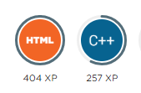anyone with an account in their website. After I created my own account, I proceeded to start with

the HTML course which was promoted to take around 8 hours to complete. In this course I learned the basics of this Hypertext Mark-up Language and acquired the skills to create simple websites and using APIs in them. After I completed this course, I started the CSS course which was advertised as a much longer course than the HTML (12 hours). I only completed about 60% of this course due to timing reasons, as I thought I was spending too much time learning the languages and was leaving the development of the website too far behind. Nevertheless, by doing this course I learned how to manipulate text and colours in a website as well as how to place images and make them look in different shapes.

## **- What type of content do I need for the subjects?**

For all of the subjects (Maths, English and science) I’m going to be looking only at what content is recommended for the Key Stage 4 course, which is equivalent to the last two years of the GCSE curriculum (Also known as Year 10 and 11). By only searching for this type of information I will be able to select much more specific content for the website, therefore making it much more useful.

In order find up-to-date information on what each subject’s main topic are I selected the National curriculum provided by the government on each subject. For every subject there is a KS4 (key stage 4) area where all the topics are shown and explained. I selected this resource as it was the most reliable and easy to use. This is the information I found out about each subject:

Maths: for mathematics at KS4 the main requirements were: Algebra, Ration, proportion, rates of change, geometry and measures, probability and finally statistics. (Department for Education 2014*)*

English: for English at KS4 the main requirements were: it focuses on spoken language, which challenges students to increase their vocabulary. Reading, which encourages students to read different books or novels from the 19th, 20th and 21st centuries. Writing, which teaches to write accurately, effectively and at length for pleasure and information. (Department for Education 2014*)*

Science: Through the content across all three disciplines, students should be taught so that they develop understanding and first-hand experience of Science. The main topic areas are: Biology, Chemistry and Physics, all of which contain a vast number of subtopics that suit each area. (Department for Education 2014*)*

With this information about the main requirements of each subject I can now work on finding resources online that would contain the named topics.

Sources.

1. Anthony S. Chow, Kathelene McCarty Smith and Katherine Sun (2012) ‘*Youth as Design Partners: Age-Appropriate Websites for Middle and High School Students’* https://www.researchgate.net/publication/298450861_Youth_as_Design_Partners_AgeAppropriate_Websites_for_Middle_and_High_School_Students (Accessed: 06 November 2018).
2. John stone (2016) *‘Millennial Appeal: How to Design a Website to Attract the Younger Audience’* https://webdesignledger.com/millennial-appeal-how-to-design-a-website-to-attract-the-younger-audience/#c4372342cc(Accessed: 13 September 2018)
3. Pluralsight (2015) *‘What's the Difference Between the Front-End and Back-End?*’ <https://www.pluralsight.com/blog/film-games/whats-difference-front-end-back-end> (Accessed: 15 September 2018)
4. Department for Education (2014*) ‘National curriculum in England: mathematics programmes of study’* <https://www.gov.uk/government/publications/national-curriculum-in-england-mathematics-programmes-of-study/national-curriculum-in-england-mathematics-programmes-of-study> (Accessed: 30 September 2018)
5. Department for Education (2014*) ‘National curriculum in England: English programmes of study’*  <https://www.gov.uk/government/publications/national-curriculum-in-england-english-programmes-of-study/national-curriculum-in-england-english-programmes-of-study#key-stage-4> (Accessed: 30 September 2018)
6. Department for Education (2014*) ‘National curriculum in England: science programmes of study’* <https://www.gov.uk/government/publications/national-curriculum-in-england-science-programmes-of-study/national-curriculum-in-england-science-programmes-of-study#key-stage-4> (Accessed: 30 September 2018)